INITIAL PHYSIOTHERAPY ASSESSMENT FORM
Date of Assessment: ___

1. PATIENT INFORMATION
Name: ___________________________________
Date of Birth: ___ / ___ / ___ Age: _______ Weight: _______ kg
Occupation: ___________________________________________
Physical Address / Residence: ___________________________________________
Telephone Number: ______________________________________

2. PRESENTING COMPLAINT
Main reason for referral / complaint:
☐ Pain ☐ Weakness ☐ Stiffness ☐ Swelling ☐ Numbness/Tingling ☐ Loss of Function ☐ Other: __________________________
Onset:
☐ Sudden ☐ Gradual ☐ Following injury ☐ Post-surgery ☐ Other: ___________
Duration:
☐ <1 week ☐ 1–4 weeks ☐ 1–3 months ☐ >3 months (chronic)
Area affected:
☐ Neck ☐ Shoulder ☐ Back ☐ Hip ☐ Knee ☐ Ankle ☐ Upper limb ☐ Lower limb ☐ Other: ___________

3. HISTORY OF PRESENTING COMPLAINT
Pain Description (tick all that apply):
☐ Sharp ☐ Dull ☐ Aching ☐ Burning ☐ Throbbing ☐ Radiating ☐ Constant ☐ Intermittent
Pain Severity (0–10 scale):
☐ 0 ☐ 1 ☐ 2 ☐ 3 ☐ 4 ☐ 5 ☐ 6 ☐ 7 ☐ 8 ☐ 9 ☐ 10
Aggravating Factors (tick all that apply):
☐ Bending ☐ Sitting ☐ Standing ☐ Walking ☐ Lying ☐ Movement ☐ Stairs ☐ Sneezing ☐ Deep Breath ☐ Prolonged Positioning ☐ Other: ___________
Easing Factors (tick all that apply):
☐ Rest ☐ Heat ☐ Ice ☐ Medication ☐ Movement ☐ Changing Position ☐ Morning Better ☐ Afternoon Better ☐ After Rest ☐ After Activity ☐ Other: ___________
24-hour pattern:
☐ Morning stiffness ☐ Night pain ☐ Improves during the day ☐ No pattern
Previous episodes: ☐ Yes ☐ No
If yes, describe: ___________________________________
Prior investigations: ☐ X-ray ☐ MRI ☐ Blood tests ☐ Ultrasound ☐ None ☐ Other: ___________
Previous treatments & outcomes:
☐ Physiotherapy ☐ Medication ☐ Surgery ☐ Injection ☐ Other: ___________
Outcome: ☐ Improved ☐ No change ☐ Worsened

4. PAST MEDICAL & SURGICAL HISTORY
Relevant medical conditions (tick all that apply):
☐ Diabetes ☐ Hypertension ☐ Heart disease ☐ Asthma ☐ Epilepsy ☐ Osteoarthritis ☐ Rheumatoid arthritis ☐ Cancer ☐ Stroke ☐ None ☐ Other: ___________
Past surgeries:
☐ Orthopaedic ☐ Cardiac ☐ Abdominal ☐ Other: ___________ Date: ___________
Current medications: ___________________________________

PERSONAL & SOCIAL HISTORY
Lifestyle factors:
☐ Smoker ☐ Non-smoker ☐ Occasional alcohol ☐ Regular exercise ☐ Sedentary lifestyle
Home environment: ☐ Independent ☐ Lives with family ☐ Assisted living ☐ Other: ___________
Work demands: ☐ Sedentary ☐ Light ☐ Moderate ☐ Heavy manual

OBJECTIVE ASSESSMENT
PAIN INTENSITY
Use symbols on body chart:
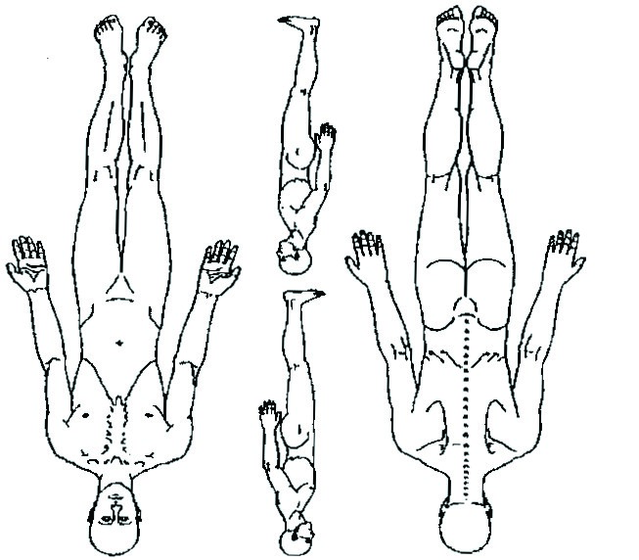
- Severe pain: *******
- Moderate pain: 000000
- Dull ache: ∩∩∩∩
- Radiating pain: ↑↓↑↓
- Numbness/Tingling: XXXXXX

OBSERVATION / INSPECTION
Posture / Alignment:
☐ Normal ☐ Kyphosis ☐ Lordosis ☐ Scoliosis ☐ Shoulder asymmetry ☐ Pelvic tilt ☐ Other: ___________
Swelling / Colour / Skin Changes:
☐ Normal ☐ Redness ☐ Bruising ☐ Oedema ☐ Scar ☐ Muscle wasting
Gait / Transfers / Function:
☐ Normal ☐ Antalgic ☐ Ataxic ☐ Trendelenburg ☐ Assistive device used ☐ Difficulty with stairs ☐ Other: ___________

PALPATION
☐ Tenderness ☐ Swelling ☐ Heat ☐ Muscle spasm ☐ Scar tissue ☐ Increased tone ☐ Reduced tone ☐ No abnormal findings

RANGE OF MOTION (ROM)
Joint / Region: ______________________
- Active: ______ °
- Passive: ______ °
- Limitation: ☐ Pain ☐ Stiffness ☐ Muscle weakness ☐ End-feel abnormality

MUSCLE STRENGTH TESTING (MMT 0–5)
Muscle Group | Grade (0–5) | Comments
__________________ | ___ | __________________
__________________ | ___ | __________________

NEUROLOGICAL SCREEN (if applicable)
Dermatomes: ☐ Normal ☐ Altered ☐ Absent
Myotomes: ☐ Normal ☐ Weakness (specify): ___________
Reflexes: ☐ Normal ☐ Hypo ☐ Hyper
Sensation: ☐ Normal ☐ Reduced ☐ Numb ☐ Tingling
Coordination / Balance: ☐ Good ☐ Fair ☐ Poor

SPECIAL / ORTHOPAEDIC / FUNCTIONAL TESTS
Test Name | Result / Finding | Positive / Negative
__________________ | __________________ | ☐ + ☐ –
__________________ | __________________ | ☐ + ☐ –
Functional Activities Tested:
☐ Sit-to-stand ☐ Stair climbing ☐ Squatting ☐ Balance ☐ Walking ☐ Other: ___________

OUTCOME MEASURES (as relevant):
☐ VAS ☐ NPRS ☐ Oswestry LBP Index ☐ Neck Disability Index ☐ WOMAC ☐ DASH ☐ Berg Balance ☐ 6MWT ☐ TUG ☐ Other: ___________

🩹 PROBLEM ANALYSIS
Prioritised Problem List:

Clinical Impression / Working Diagnosis:
☐ Musculoskeletal ☐ Neurological ☐ Cardiopulmonary ☐ Post-surgical ☐ Other: ___________
Clinical Summary: _____________________________________________

🎯 GOALS & TREATMENT PLAN
Short-Term Goals (1–2 weeks):
☐ Reduce pain ☐ Improve ROM ☐ Increase strength ☐ Improve mobility ☐ Enhance function ☐ Patient education
Long-Term Goals (by discharge):
☐ Restore full function ☐ Independence in ADLs ☐ Return to work ☐ Improve endurance ☐ Prevent recurrence

TREATMENT PLAN & INTERVENTIONS
☐ Manual therapy ☐ Exercise therapy ☐ Electrotherapy ☐ Hydrotherapy ☐ Education ☐ Posture correction ☐ Home exercise program ☐ Gait re-education ☐ Other: ___________
Frequency of treatment: ☐ Daily ☐ Twice weekly ☐ Weekly ☐ Other: ___________
Expected duration: __________ weeks

REVIEW & REASSESSMENT
Next review date: ___ / ___ / ___
Outcome: ☐ Improved ☐ No change ☐ Deteriorated ☐ Discharged
Physiotherapist Name: ________________________
Signature: ________________________
Date: ___ / ___ / ___

